**Data Analysis of Globally**

**based Hotel Bookings**

**Business Problem :**

**In recent years, City Hotel and Resort Hotel have seen high cancellation rates. Each**

**hotel is now dealing with a number of issues as a result, including fewer revenues and**

**less than ideal hotel room use. Consequently, lowering cancellation rates is both hotels'**

**primary goal in order to increase their efficiency in generating revenue, and for us to**

**offer thorough business advice to address this problem.**

**The analysis of hotel booking cancellations as well as other factors that have no bearing**

**on their business and yearly revenue generation are the main topics of this report**.

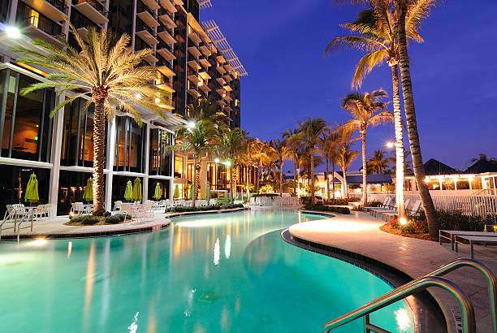

**Assumptions :**

**1. No unusual occurrences between 2015 and 2017 will have a substantial impact on**

**the data used.**

**2. The information is still current and can be used to analyze a hotel's possible plans in**

**an efficient manner.**

**3. There are no unanticipated negatives to the hotel employing any advised technique.**

**4. The hotels are not currently using any of the suggested solutions.**

**5. The biggest factor affecting the effectiveness of earning income is booking**

**cancellations.**

**6. Cancellations result in vacant rooms for the booked length of time.**

**7. Clients make hotel reservations the same year they make cancellations.**

**Research Question :**

**1. What are the variables that affect hotel reservation cancellations?**

**2. How can we make hotel reservations cancellations better?**

**3. How will hotels be assisted in making pricing and promotional decisions?**

**Hypothesis :**

**1. More cancellations occur when prices are higher.**

**2. When there is a longer waiting list, customers tend to cancel more frequently.**

**3. The majority of clients are coming from offline travel agents to make their**

**reservations.**

**Analysis and Findings :**

**The accompanying bar graph shows the percentage of reservations that are canceled**

**and those that are not. It is obvious that there are still a significant number of**

**reservations that have not been canceled. There are still 37% of clients who canceled**

**their reservation, which has a significant impact on the hotels' earnings.**

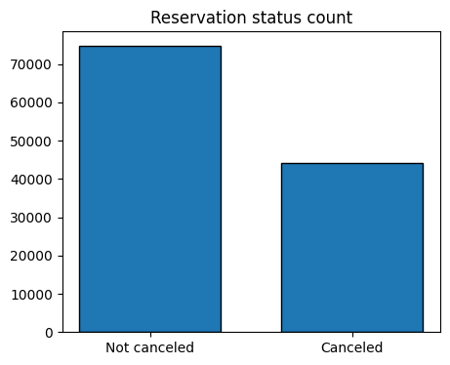

**In comparison to resort hotels, city hotels have more bookings. It's possible that resort**

**hotels are more expensive than those in cities.**

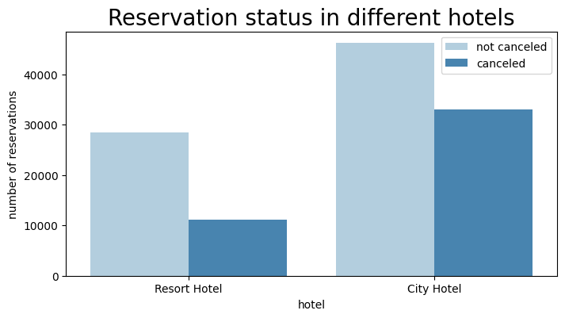

**The line graph above shows that, on certain days, the average daily rate for a city hotel**

**is less than that of a resort hotel, and on other days, it is even less. It goes without**

**saying that weekends and holidays may see a rise in resort hotel rates**.

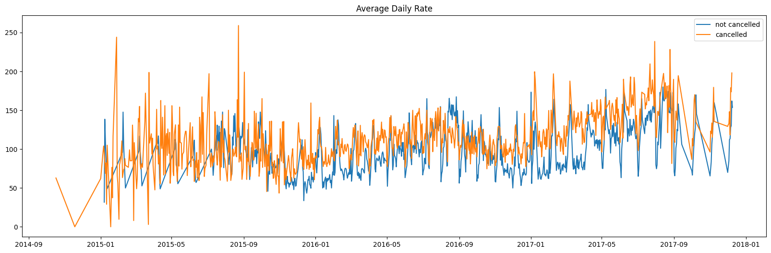

**We have developed the grouped bar graph to analyze the months with the highest and**

**lowest reservation levels according to reservation status. As can be seen, both the**

**number of confirmed reservations and the number of canceled reservations are largest**

**in the month of August. whereas January is the month with the most canceled**

**reservations.**

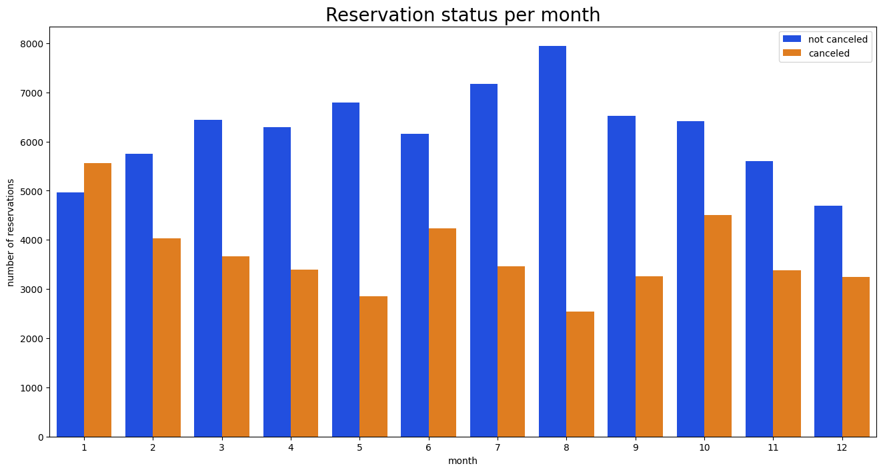

**This bar graph demonstrates that cancellations are most common when prices are**

**greatest and are least common when they are lowest. Therefore, the cost of the**

**accommodation is solely responsible for the cancellation.**

**Now, let's see which country has the highest reservation canceled. The top country is**

**Portugal with the highest number of cancellations.**

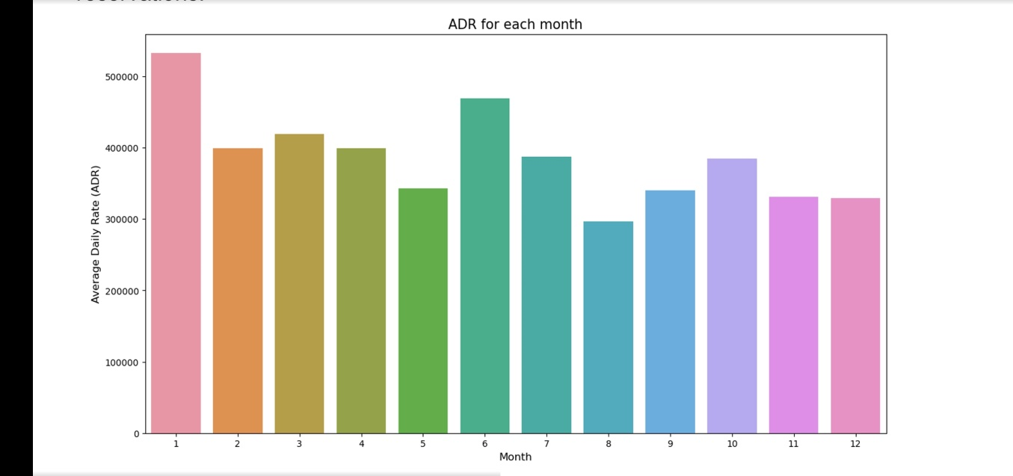

**Let’s check the area from where guests are visiting the hotels and making reservations.**

**Is it coming from Direct or Groups, Online or Offline Travel Agents? Around 46% of the**

**clients come from online travel agencies, whereas 27% come from groups. Only 4% of**

**clients book hotels directly by visiting them and making reservations**.

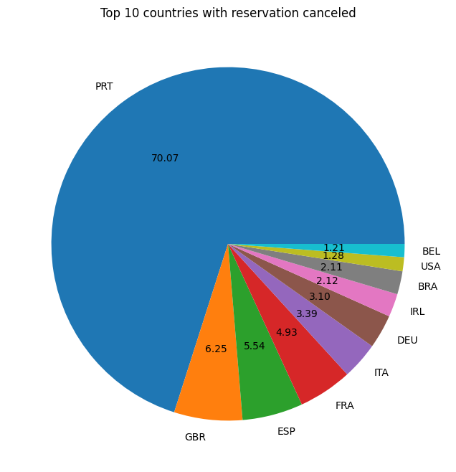

**As seen in the graph, reservations are canceled when the average daily rate is higher**

**than when it is not canceled. It clearly proves all the above analysis, that the higher**

**price leads to higher cancellation.**

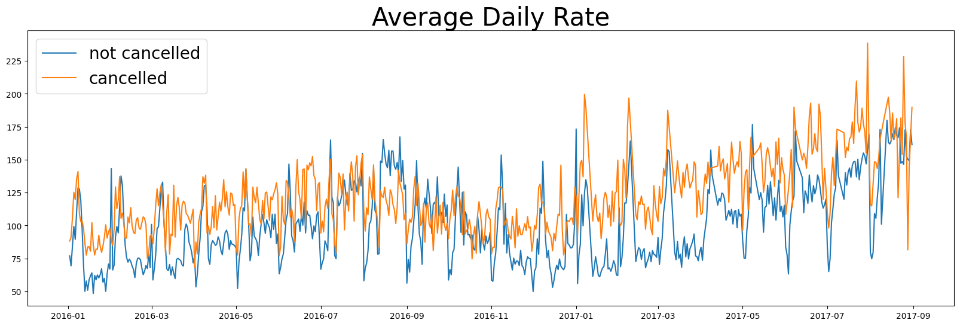

**Suggestions :**

**1. Cancellation rates rise as the price does. In order to prevent cancellations of**

**reservations, hotels could work on their pricing strategies and try to lower the**

**rates for specific hotels based on locations. They can also provide some**

**discounts to the consumers.**

**2. As the ratio of the cancellation and not cancellation of the resort hotel is higher in**

**the resort hotel than the city hotels. So the hotels should provide a reasonable**

**discount on the room prices on weekends or on holidays.**

**3. In the month of January, hotels can start campaigns or marketing with a**

**reasonable amount to increase their revenue as the cancellation is the highest in**

**this month.**

**4. They can also increase the quality of their hotels and their services mainly in**

**Portugal to reduce the cancellation rate.**